Revision For the Creative Digital Media Exam



For the exam you must be able to show that you:
A understand digital media sectors, products and platforms
B understand audiences for digital media products
C explore how audiences engage with digital media products

Media Sectors:
Which media sector do the following products belong to?

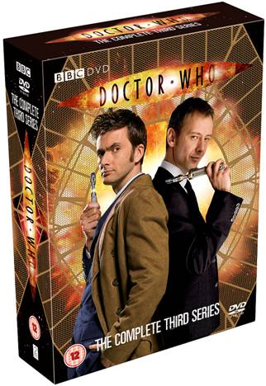





Complete the sentence
Media Synergy is…

Pre-production, Production and Post-production: Sort the below tasks into the area of production

Pre-Production | Production | Post-Production

Script Writing Editing video footage Storyboards Filming Footage Writing articles

Research Taking Photographs Altering images Adding soundtracks

Media platforms: Media platforms are how we can break down the larger media sectors.

What kinds of platforms can we view MOVING IMAGE MEDIA on?

What kinds of platforms can we view PRINT MEDIA on?

Complete the following sentence:
Cross Media Convergence is…

___________________________________________________________________________________________

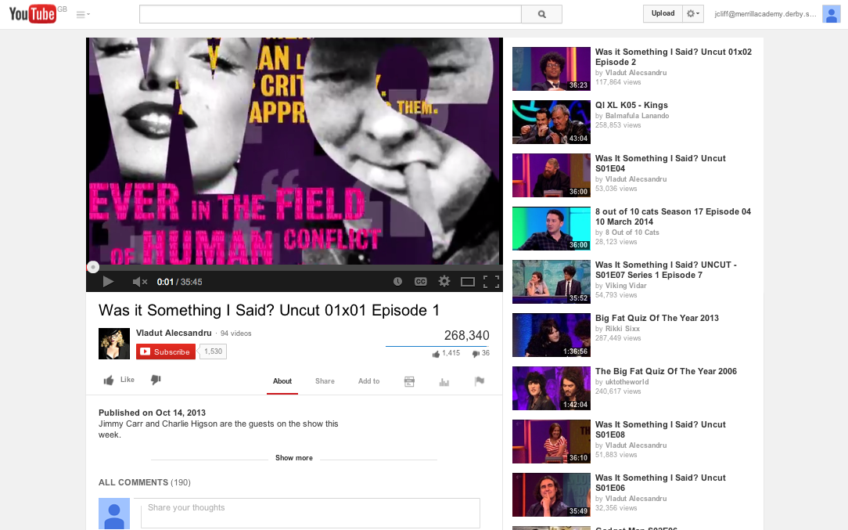
Look at the web page below…

How can the page be personalised for the user?
______________________________________________________________________________________________________________________________________________________________________________________

What features are interactive for the user?
______________________________________________________________________________________________________________________________________________________________________________________

Audiences:
Individual audiences – On their own
Group audiences – More than one person

Sort the following into group and individual audiences:

Group Audience | Individual Audience

Watching a film in the cinema. Reading a magazine
Viewing a Billboard surfing the Internet
Listening to music on an MP3 player Playing on Xbox Live

ACTIVE AUDIENCES: Complete the sentence.

Active audiences are…

We call media products made by audiences (and shared on sites like Youtube)

PASSIVE AUDIENCES:

What is the theory (model) that we use when talking about audiences being passive?
Hint – look at the image!
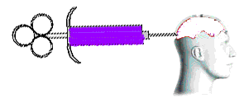

What are three problems with this theory?

Who are these regulators and what do they regulate?
 | Full Name | What they regulate
PCC
ASA
BBFC
PEGI
OFCOM

Audience research: complete these sentences
Primary Research is…

Secondary Research is…

Give one example of primary research and one example of secondary research.
Primary research | Secondary research

- Qualitative results give detail and opinion.
- Quantitative Results can be put into tables and graphs. They are simple.

Circle all the quantitative questions below (4):

Do you like Chocolate? | Who is your best friend and why?
What is your earliest memory? | What is your favourite colour?
What time did you wake up this morning? | How many brothers and sisters do you have?

- Objective questions give measurable closed information
- Subjective questions are opinion based and can be influenced.

Circle all the subjective questions (3):
Do you like my beautiful hat? | What is your name? | What would you like for dinner?
How do you feel? | Do you want Pizza for lunch? | What do you think of Crazy Pete?
Demographic is an important media term – give a definition of demographic.

Demographic:

Complete the Brainstorm:

Eg. Age

What different ways can we classify
or identify an audience’s demographic?

For your reference: The A-E class rating of demographics.

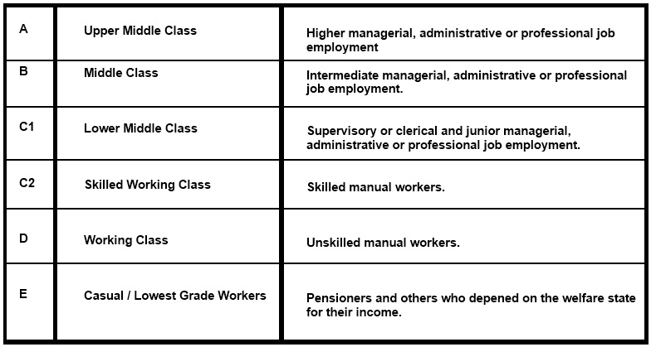

Creating Meaning:

Objects, colour, costume and sounds… almost everything can create meaning for an audience.

Denotation | The object or sound itself
Connotation

Look at the images below: list the connotations for each.







Misé en Scene is French for ______________________________________________

It is made up of:

The Misé en Scene of this image tells me it it part of the ______________ genre.

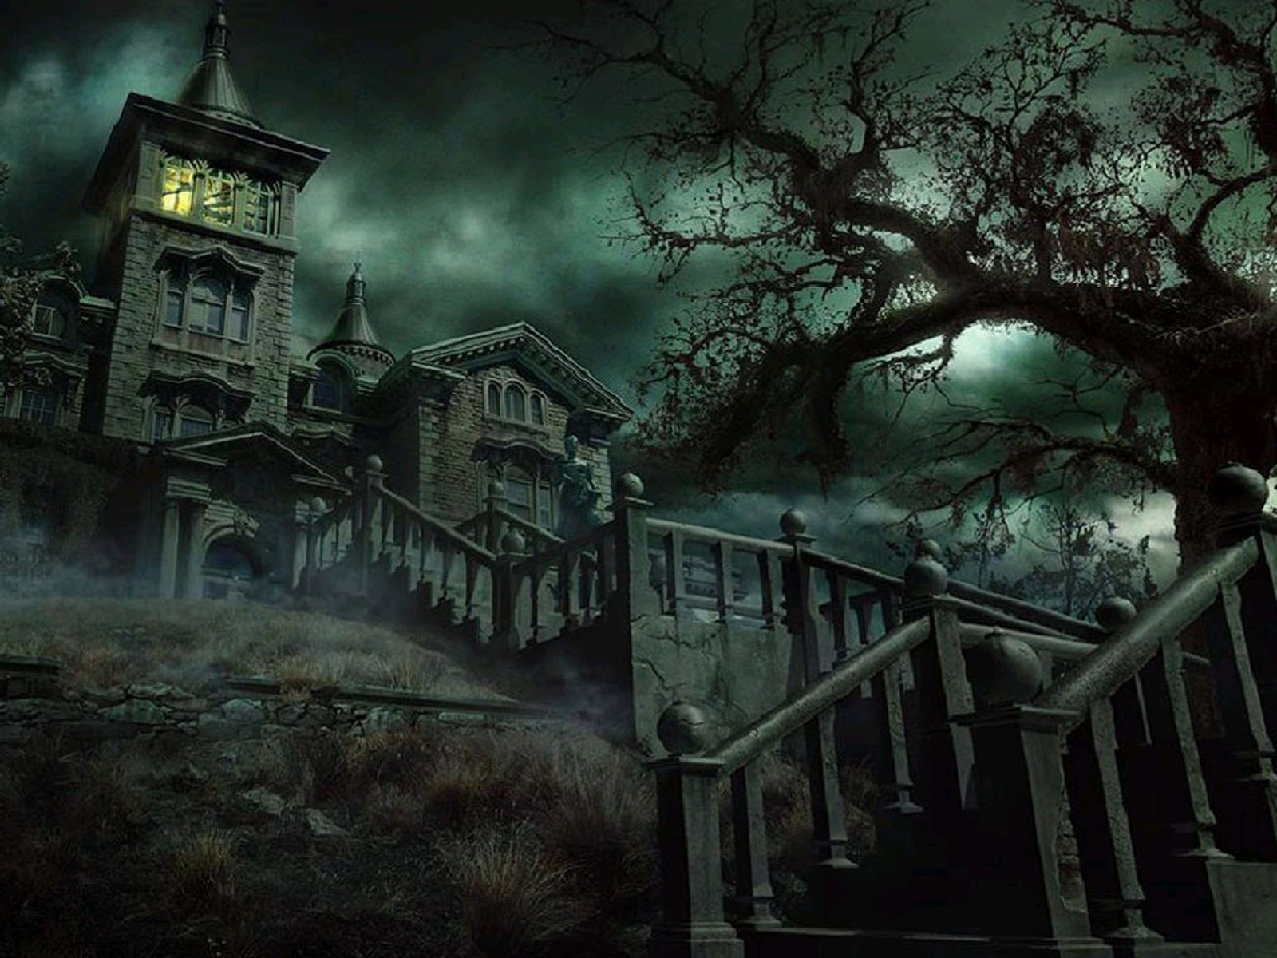

The specific parts that tell me this are:

Lighting is key to creating meaning:

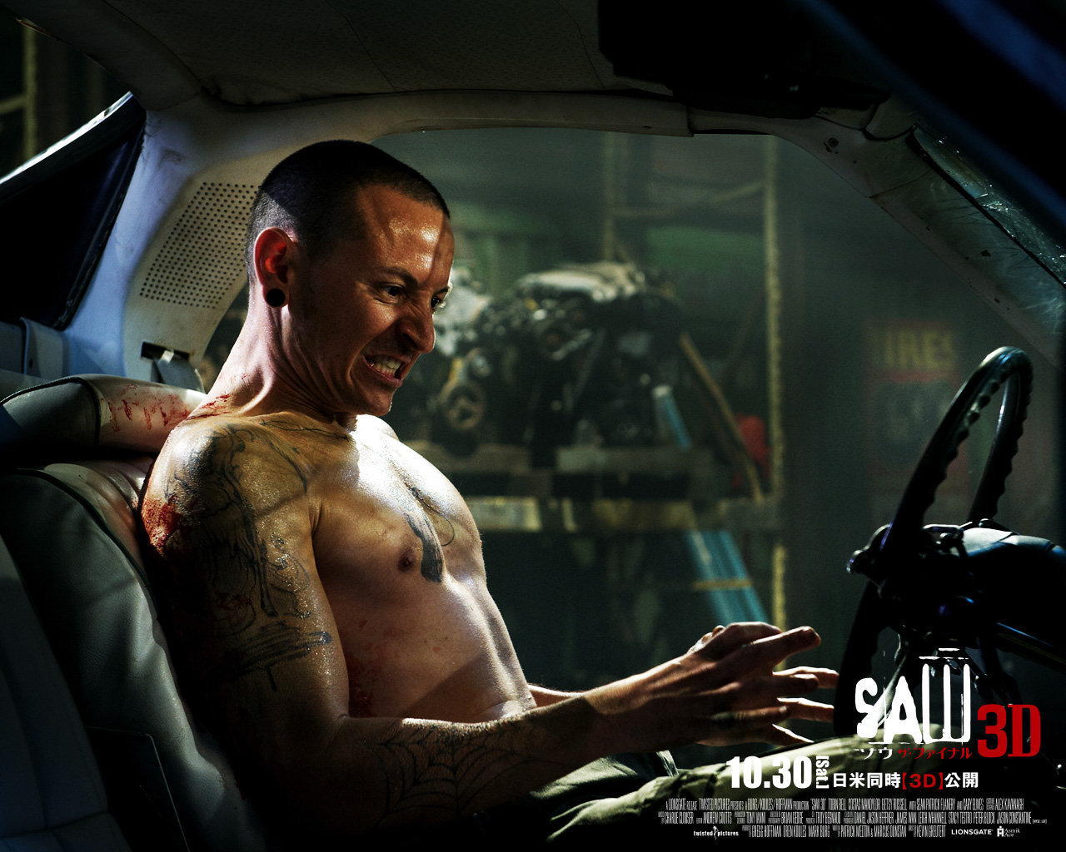 This image shows ____________________ lighting

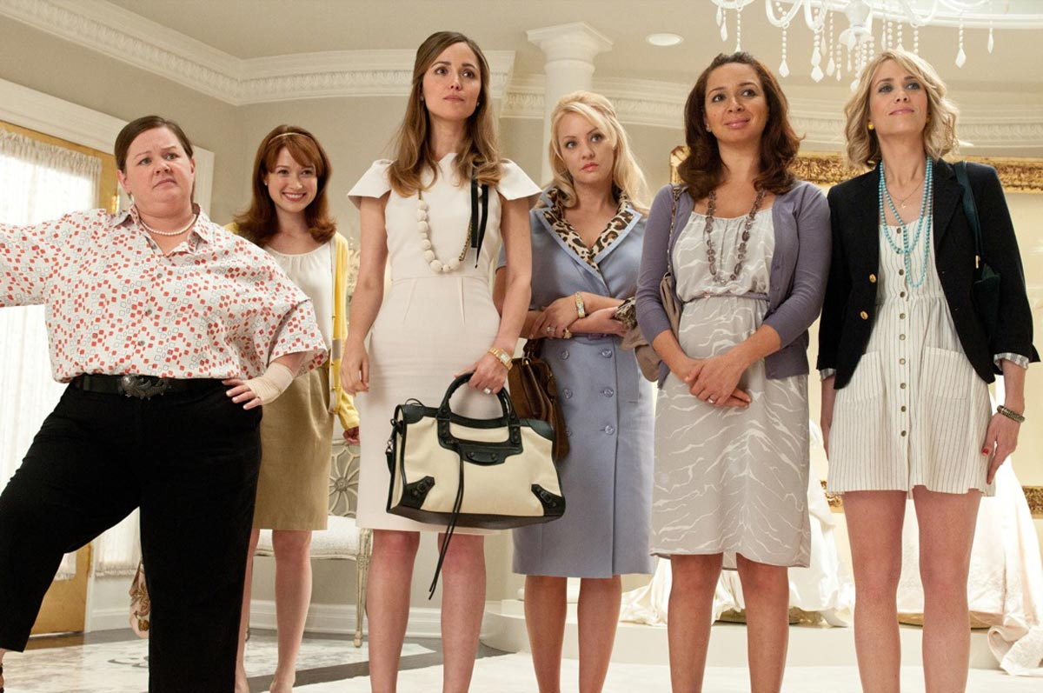 This image shows ____________________ lighting

Colour can also create meaning especially for genre or the time when a piece is set.
Hue is the name we give to a colour cast of images/film.

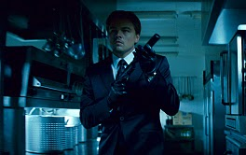
This image is from Inception. It has a very blue/green hue. What does this tell you about the genre or time setting of the film?

_______________________________________

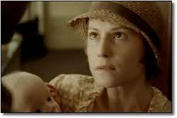
This image has a sepia hue. What does this tell you about the genre or time setting of the piece?

_______________________________________

Label the camera shots below:

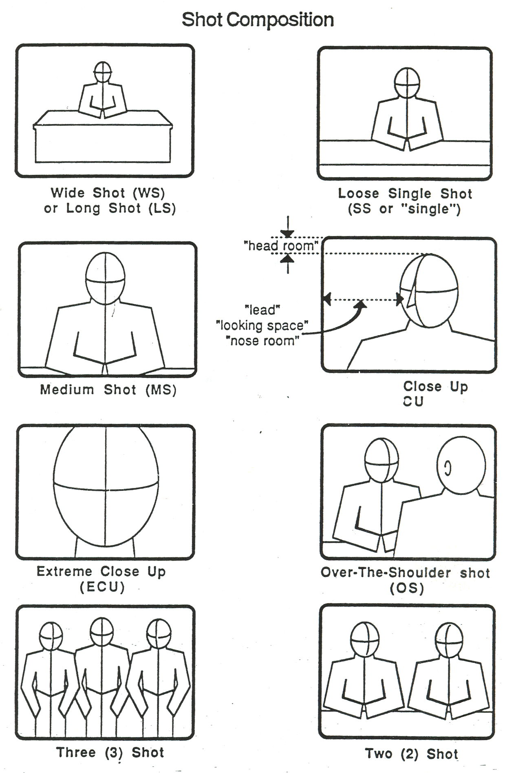

Camera movement
Describe the following camera movements.

Pan
Tilt
Tracking

Sounds can be Non-Diegetic and Diegetic. Explain what this means.

 | Explanation | Example.
Diegetic sound
Non Diegetic sound

The story: the proper media term for story is __________________________

Look at the following flow charts. What kinds of narrative do they show?

Start
End
Middle
1.

Start

Amy’s Story Start
Martin’s Story Start
Matt’s Story Start

2.

Matt’s Story End
Martin’s Story End
Amy’s Story End

End

Return
to
present
Flash Back
End
3.
Start

Front cover analysis:

Kerrang is a _______________________________magazine
^{(Genre)}


The lighting is

__________________

The colours used are:

These have been used because they have connotations of…

__________________________________________________________________________________________________________________

The hair and make up I can see is:
The props I can see are:

This is significant because…
These are significant because…

