Directors commentary
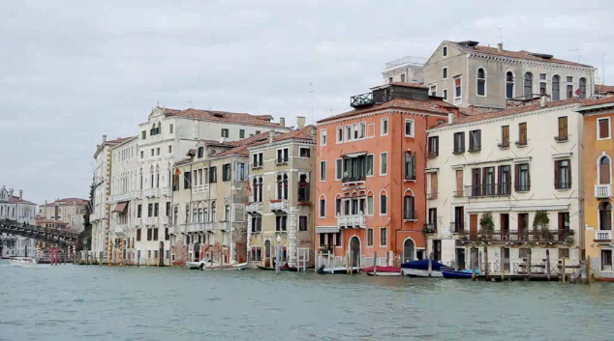
Since my film is filmed in Venice I decided that the beginning shots should be location shots of famous icons/ objects that perfectly reflect Venice e.g. I did a time-lapse of the Grand Canal for the very first shot so the audience can instantly recognise the buildings and the canal to be Venice and I also used another location shot for the beginning shots was St Mark’s square with pigeons. Having both of the location shots and the song ‘that’s amore’ by Dean Martin perfectly symbolise Italy

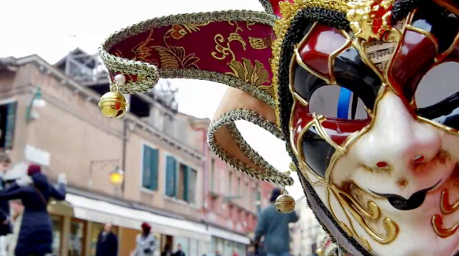

Since I have done location shots of The Grand Canal and St Mark’s Square I decided to add in a short clip of an object that perfectly symbolizes Venice: venetian masks. I filmed a venetian mask hanging off a stall for this.

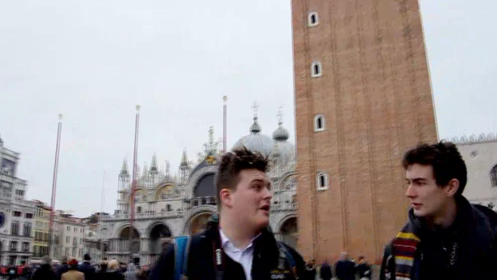

The first scene where the actors are talking I decided to have the West Façade of St Marks’s Basilica and the tower in the background since this is a well-known landmark that hopefully the audience will know so will know where the actors are easily.

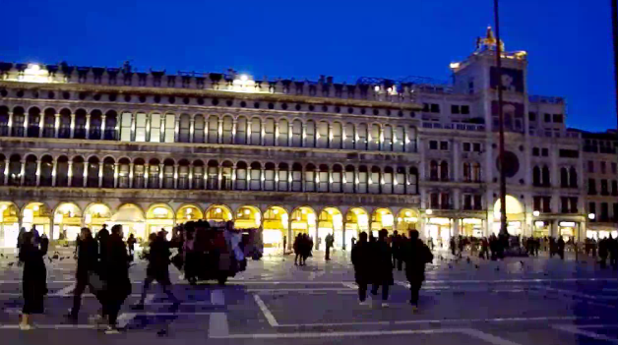
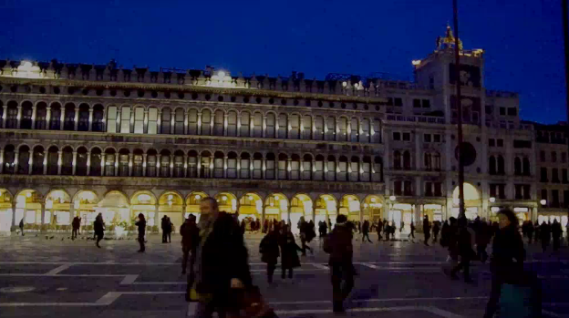
I decided to have a time-lapse of St Mark’s Square in the evening since the sky gets gradually darker showing the audience that its getting darker which will tell the audience that it’s now the evening for the rest of the film.

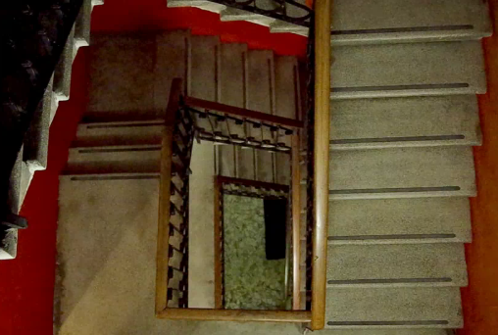
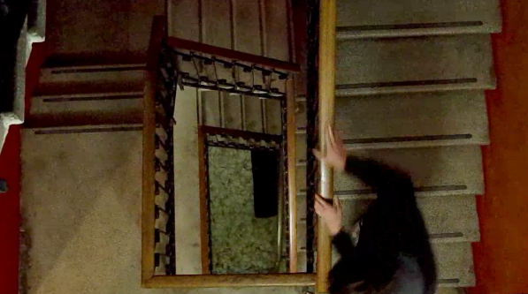
I am very proud on this camera angle in the Hotel Altantide in which Wilson and Robbie will walk up the stairs and another shot of Robbie running down the stairs with bells ringing. I used this angle as high angle tends to represent overpower and ‘looking down’ this fits perfectly with Robbie running down the stairs trying to run away from the possessed Wilson.

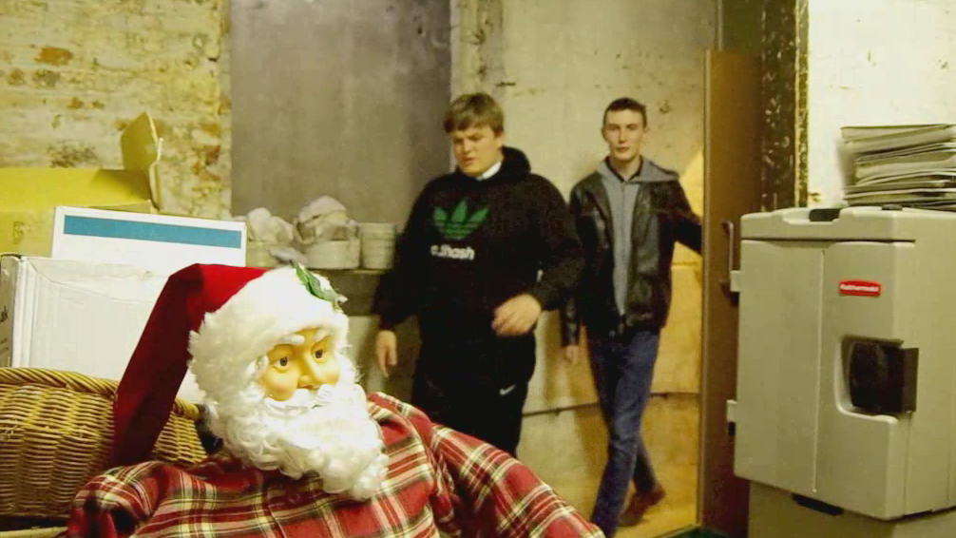
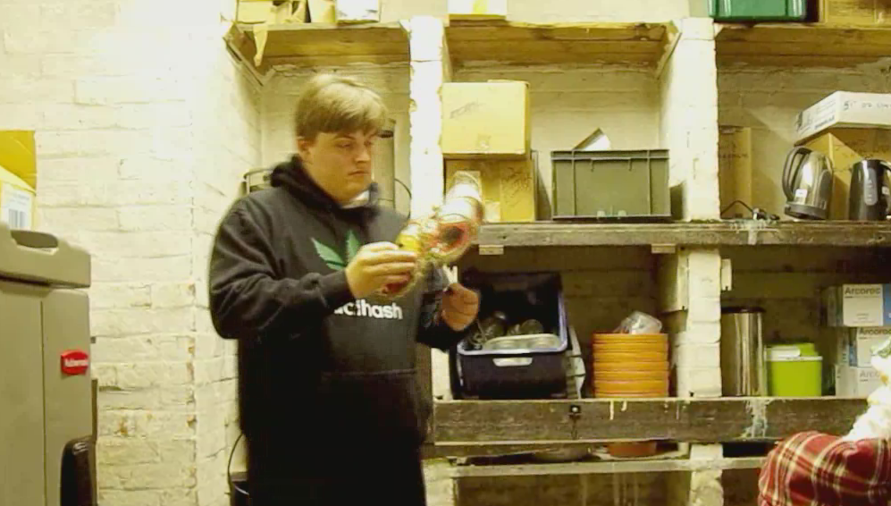
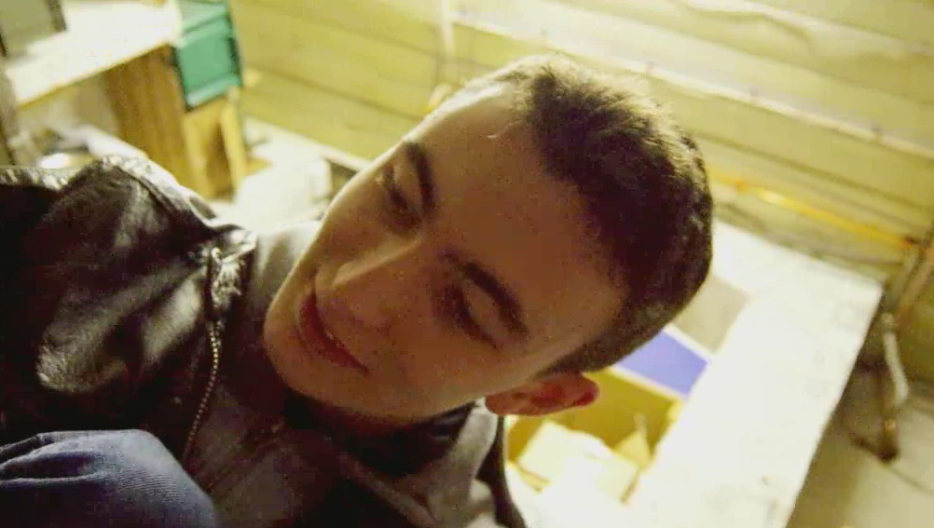
This is the first shot of Wilson and Robbie in the room (basement of More House School) I decided to have the Santa in the shot as it creates an unsettling feeling as it is very creepy. Having this creepy Santa also foreshadows that this room is not what it looks like.
For this shot, I pan zoomed onto Wilson when he finds the mask, pan zooming means Wilson is the centre of attention. Zooming in on him means something is going to happen, either good or bad.
Using a Dutch angle shows that Robbie is worried for Wilson and doesn’t know what is happening. This tense moment also worries the audience on what is wrong.
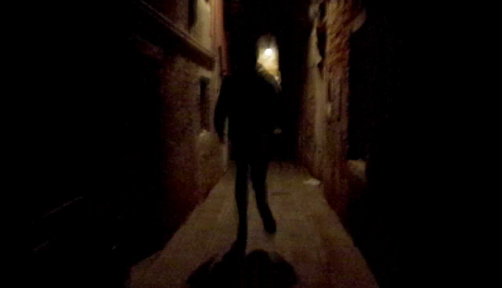
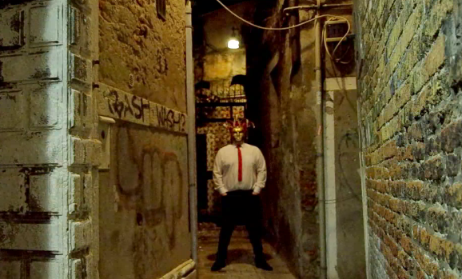
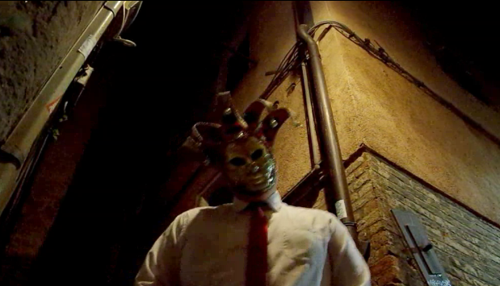
This camera shot was a handheld shot of me running behind Robbie. This symbolises Robbie getting chased and impending doom. Using a handheld shot helps the audience get a better perspective of Robbie running in fear.
I used this camera angle as when you have Wilson in the mask where he is, there is good rule of three with Wilson being in the centre of the shot so therefore the centre of attention
Using POV of Robbie helps the audience have a better perspective and using a low angle shows over empowerment since he is looking up. Wilson moving in towards the camera creates an unsettling feeling for the audience

